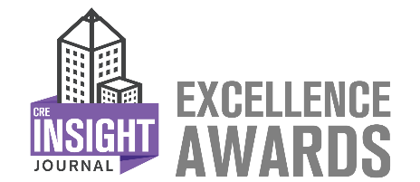
2026 Excellence in Adaptive Reuse Application
This award recognizes both newly converted adaptive reuse properties and assets that have undergone significant enhancements following a previous adaptive reuse conversion. You may complete this application based on either scenario. Please refer to the structured questions below when sharing your property’s story.
To enter, complete the following application in entirety. Following completion, upload this application to https://creinsightjournal.com/submissions/ or send it to info@creinsightjournal.com along with a picture representing the award submission (building photo, staff photo, or other representative image). Entries must be received no later than June 15, 2026. For more information on this awards program, go to www.CREInsightJournal.com/awards.

Building Name:
Building Management Company Name:
Applicant Full Name:
Applicant Title:
Phone Number:
Email Address:
Website:
Company LinkedIn Account:
Company Twitter Account:

1) Describe your property’s adaptive reuse journey. Was your property recently converted to adaptive reuse, or was it previously adapted and then further enhanced? Please outline your adaptive reuse goals—either for the initial conversion, subsequent improvements, or both—as well as the progress made toward achieving those goals. (800 word maximum)

2) Detail the scope of work and projects associated with your adaptive reuse initiative. For newly converted assets: Describe the process of adapting the property to its new use. For previously adapted assets: Describe the enhancements, upgrades, or additional adaptive reuse initiatives your team has undertaken since the original conversion. (800 word maximum)

3) Explain the impact of your property’s adaptive reuse efforts—whether through initial conversion or subsequent enhancements—on tenants, visitors, and/or the local community. Please specify how the changes have influenced the property's function, appeal, and role in the community. (800 word maximum)

