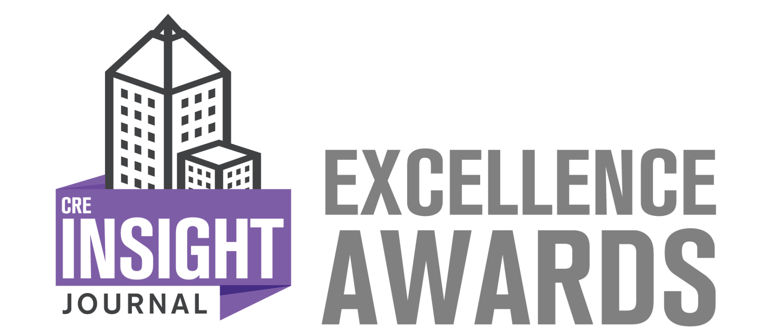
2024 Excellence in Collaborative Service Application
This award recognizes an exemplary partnership between a building and a product or service provider partner. Building management teams and product/service providers often collaborate to improve operational efficiency, environmental sustainability, tenant care, and more. This award recognizes excellence in this type of collaboration.
To enter, complete the following application in entirety. Following completion, upload this application to https://creinsightjournal.com/submissions/ or send it to info@creinsightjournal.com along with a picture representing the award submission (building photo, staff photo, or other representative image). Entries must be received no later than June 15, 2024. For more information on this awards program, go to www.CREInsightJournal.com/awards.
Building Name:
Building Management Company Name:
Product/Service Partner Company Name:
Applicant Name:
Applicant Title:
Phone Number:
Email Address:
Website:
Company LinkedIn Account:
Company Twitter Account:

1) Describe the purpose of the collaboration between the building management team and the product/service provider and any associated goals. (600 word maximum)
By cultivating open lines of communication and shared objectives for achievement, collaboration facilitates the alignment of project objectives, the minimization of delays, and the prevention of costly errors for all parties involved. The synergy between service partners and management fosters a seamless workflow, allowing for efficient coordination and the execution of an end product that benefits not only the building, clients, tenants, and manager, but also the service partners themselves.
2) Describe the results achieved from the collaboration, including data and/or metrics where possible. (800 word maximum)
This project underscored the vital importance of cultivating a relationship of trust and collaboration with both clients and service providers. Effective communication regarding client requirements and deadlines enabled Lincoln Property Company and Gray Contracting to not only meet but surpass all expectations. With the client and vendor staying in constant communication, management was able to have discussions with the tenants to ensure that their workflow and quality of their workspace remained undisturbed. Effective communication proves to the linchpin of success. Ultimately, the ability to communicate effectively with clients is indispensable for understanding their needs, building trust, managing expectations, problem-solving, and ensuring satisfaction. It, in turn, contributes to sustained business success and expansion.
3) What key lessons were learned from this partnership? How can other building management teams and/or product/service providers learn from this collaboration? (600 word maximum)

